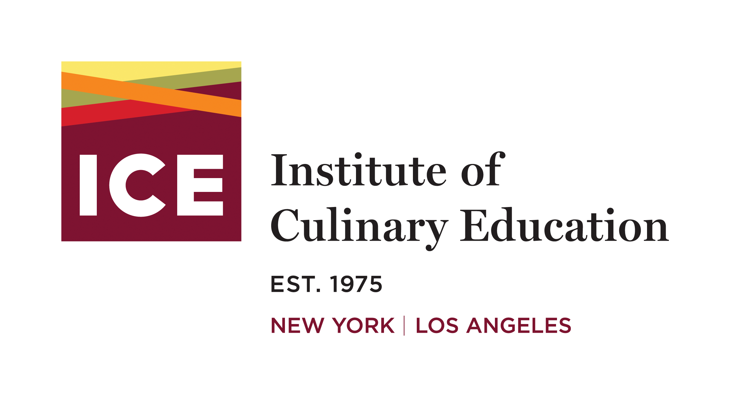

521 E. Green St
Pasadena CA 91101
626-345-6601
www.ice.edu

INTERNATIONAL STUDENT GUIDELINES

Thank you for your interest in studying at the Institute of Culinary Education. ICE is pleased to welcome international students to its career-training programs. Refer to the following International Student Guidelines to help you understand the requirements for the M-1 and F-1 visa process. All programs at ICE are taught in English.

Table of Contents

ENROLLING AT THE INSTITUTE OF CULINARY EDUCATION 2
DEMONSTRATING ENGLISH PROFICIENCY 3
REQUESTING THE FORM I-20, APPLICATION FOR CERTIFICATE OF ELIGIBILITY FOR NONIMMIGRANT STUDENT STATUS FOR VOCATIONAL STUDENTS 4
DEMONSTRATING FINANCIAL RESOURCES 4
SEVIS FEE 5
APPLYING FOR A STUDENT VISA 6
UPON ARRIVAL AND MAINTAINING STUDENT STATUS WHILE IN THE U.S. 7
PRACTICAL TRAINING (PT) AND WORK OPTIONS for M-1 and F-1 STUDENTS 8
M-1/F-1 VISA ACKNOWLEDGEMENT 9

ENROLLING AT THE INSTITUTE OF CULINARY EDUCATION

M-1 Visa (Vocational Student Visa)
All international students who wish to attend ICE must first apply and enroll before any student visa applications can be released. International students seeking an M-1 visa are eligible to enroll in the below career programs and schedules at the Los Angeles Campus:

Career Culinary Arts Diploma
7:30AM - 11:30PM Monday-Friday
12:00PM - 4:00PM Monday-Friday

Career Pastry & Baking Arts Diploma
7:30AM - 11:30PM Monday-Friday
12:00PM - 4:00PM Monday-Friday

Career Health-Supportive Culinary Arts Diploma
7:30AM - 11:30PM Monday-Friday
12:00PM - 4:00PM Monday-Friday

International students who would like to participate in the Diploma in Restaurant & Culinary Management program must take it concurrently with the Culinary Arts, Pastry & Baking Arts, or Career Health-Supportive Culinary Arts Programs. The Diploma in Restaurant & Culinary Management is not an eligible program by itself for international students seeking an M-1 visa. It is, however, an eligible program for a student with a valid status in the United States.

International students who will be traveling to ICE on a visa other than an M-1 or F-1 should visit the SEVIS website to confirm their visa will allow them to enroll in vocational training or academic education. A copy of the existing visa must be provided to ICE prior to enrollment.

F-1 Visa (Academic Student Visa)
All international students who wish to attend ICE must first apply and enroll before any student visa applications can be released. International students seeking an F-1 visa are eligible to enroll in the below academic programs at the Los Angeles Campus:

Associate of Occupational Students in Culinary Arts & Management

Associate of Occupational Students in Pastry and Baking Arts & Management

Associate of Occupational Students in Health-Supportive Culinary & Management

The schedules for the AOS programs are variable and will have classes in the mornings, afternoons, and evenings at different times during the program.

International students who will be traveling to ICE on a visa other than an M-1 or F-1 should visit the SEVIS website to confirm their visa will allow them to enroll in vocational training or academic education. A copy of the existing visa must be provided to ICE at enrollment.

Process and Procedure for M-1 and F-1 Students
To enroll at ICE, all international students regardless of either visa type must provide the below:
- Completed Application for Admission along with non-refundable $85 registration fee (https://forms.ice.edu/onlineapp/olacctpg.aspx).
- Education documentation demonstrating at least completion of a high school diploma.
  - International documentation must be accompanied by an official, certified translation and evaluation noting that the student has completed the equivalent of a secondary school in the United States of America.
    - Trusted resources for education evaluations include Trustforte Language Services (https://www.trustforelanguages.com) and Globe Language Services (https://www.globelanguage.com), among others. Speak with your Admissions Representative if you have any questions.
- Proof of English proficiency (see page 3).
- Valid government-issued photo identification that has not expired.
- Signed Enrollment Agreement.
- Signed Contract to Make Payment in Full Prior to Class Start Date along with 10% initial tuition payment.
- COVID VACCINATION: As of 12/7/21, all students using an M-1 or F-1 visa must show proof of COVID-19 vaccination to the Department of Homeland Security upon entering the United States.

DEMONSTRATING ENGLISH PROFICIENCY

The Institute of Culinary Education requires that its students be able to speak, read, write and understand English fluently. We are required to collect proof of English language proficiency for all non-native speakers who wish to study here. Below are recognized ways to demonstrate English language proficiency:
- Graduation from an English-speaking secondary institution (high school).
- Evidence of having completed 12 semester hours or 18 quarter hours with at least a ‘C’ (70%) average at an accredited postsecondary institution in which English was the language of instruction.
- English Language School/ESL Programs: If you have attended an English language school or ESL program, you may provide documentation from the school proving that you have successfully completed the coursework that is equivalent to a score of 500 in the TOEFL exam.
- Test of English as a Foreign Language (TOEFL) score of at least:
  - 500 - paper version
  - 173 - computerized version
  - 61 - internet-based version
- International English Language Testing System (IELTS) score of at least 6.
- Common European Framework of Reference (CEFR) score of at least B2.
- Duolingo English Test score of at least 95.
- ICE ESL Exam scoring 42 points or higher.

REQUESTING THE FORM I-20, APPLICATION FOR CERTIFICATE OF ELIGIBILITY FOR NONIMMIGRANT STUDENT STATUS FOR VOCATIONAL STUDENTS

In addition to documentation listed above for enrollment, ICE will need to receive the following items in order to release your I-20 for an M-1 or F-1 visa:
- A complete, legible copy of your passport, including all pages from front to back cover.
- Proof of financial resources (see below).
- Copies of any previous visas to the United States.
- Proof of living arrangements for program duration.
- Verification of home address and phone number that you will be returning to upon completion of study.
- 1-94 Release Form.
- SignedVisa Acknowledgment (last page of this document).

If you will also need a spousal or dependent M-2, or F-2 visa, ICE will additionally need:
- A complete and legible copy of the passport(s) for all additional parties.
- Proof of relationship to student (marriage or birth certificates).
- Proof of financial resources to support dependents.

DEMONSTRATING FINANCIAL RESOURCES

International students are required to prove that they have funds to pay for the entire tuition including, but not limited to, books, uniforms, knives, and tool kits plus the cost of living while studying at the Institute of Culinary Education. The requirements are as below:
- Prior to enrollment, internationals students must make a 10% initial tuition payment and sign a Contract to Make Payment in Full Prior to Class Start Date.
- Proof of funds for your education and living expenses must be demonstrated by providing a letter of certification that meets all of the following criteria:
  - If funds are in student's name, a letter meeting the following criteria must be met:
    - Written in English
    - Typed on bank letterhead
    - Signed by a bank official
    - Dated within 6 months of the start date of the program
    - List account number(s)
    - List specific balance of account(s) in U.S. dollars
      - Balance of account(s) must cover full tuition and at least $3327.75 per month for living expenses for the duration of the program (see below if sponsor is providing room and board)
      - No letters can be accepted that do not specify exact balances unless the bank attests that the balance is a minimum of $100,000
    - Every person named on the bank account (other than the student) must provide a letter of support stating that the funds in the account can be used to fund the student's education and living expenses
  - If the student's education and/or living expenses are being paid by another individual, that person must register with the Department of Homeland Security as a sponsor. This includes sponsors providing room and board.
    - Sponsor must complete and file the USCIS form I-134, Affidavit of Support (https://www.uscis.gov/i-134).
      - Filing instructions can be obtained by calling the USCIS National Customer Service Center at 1-800-375-5283.
      - When the sponsor receives confirmation of filing, both the affidavit and the confirmation must be submitted to ICE.
    - A letter must accompany the confirmation and Affidavit of Support that:
      - Is written in English
      - Is dated within 6 months of the start date of the program
      - Specifies the sponsor's relationship to the student
      - Lists the name of the bank and account numbers that are stated to be intended for support of the student
      - Be accompanied by a copy of a bank statement in U.S. dollars to verify the minimum balance of the full tuition plus at least $2,200 per month for living expenses (see below if student's room and board are being provided by a sponsor)

SEVIS FEE

The Student Exchange Visitor Information System (SEVIS) is an internet system that maintains information on non-immigrant students, exchange visitors, and their dependents. The fee­ supported system enabled schools and program sponsors to transmit information to the Immigration and Customs Enforcement and Department of State throughout a student or exchange visitor's stay in the United States.

Once you have received the I-20, application for Certificate of Eligibility for Nonimmigrant Student Status, the USCIS requires that you pay the SEVIS I-901 fee before applying for a student visa.

The easiest way to pay the SEVIS fee is at www.fmjfee.com. You will be given an option to pay by credit/debit card, check, or money order drawn on a financial institution in the United States and payable in U.S. currency. A receipt will be provided when you pay online. Please be sure to print the receipt as it will be needed for your visa interview. A receipt will also be mailed to you, but it may not be received in time.

APPLYING FOR A STUDENT VISA

In order to be able to come to the United States of America and attend the Institute of Culinary Education, you must contact your nearest U.S. embassy or consulate and apply for an M-1, or F-1 student visa. Visit www.usembassy.gov for a list of embassy locations.

First-time student visa applicants are required to appear for an in-person interview. Each embassy and consulate will have their own procedures and policies when processing student visas. Please be sure to check with your specific consulate or embassy before arriving for your interview. In addition, if your primary residence is not your home country of citizenship, you must apply at the U.S. embassy in your country of residence.

Required items to apply for an M-1 student visa:
- Form I-20 obtained from the Institute of Culinary Education. The form must be signed by a Designated School Official and the prospective applicant.
- Form DS-160 with form DS-158. Both forms must be completed and signed and the confirmation pages printed. Some applicants will be required to complete and sign Form DS-157. Separate forms will be required for children. Form DS-160, Online Nonimmigrant Visa Application, can be found at https:/ /ceac.state.gov/genniv/. Form DS-158 can be found at https://eforms.state.gov/Forms/ds158.PDF.
- Passport - Must be valid for a minimum of six months after your intended period of stay in the U.S.
- One (1) 2x2 Photograph - Nonimmigrant photograph requirements can be found at https://travel.state.gov/content/travel/en/us-visas/visa-information-resources/photos.html
- SEVIS Fee Receipt - This was provided to you when you processed your payment online. A copy of the receipt will also be mailed to you at the address you supplied when you made the payment.
- Proof of English Language Ability (see Demonstrating English Proficiency).
- Proof of Financial Resources (see Demonstrating Financial Resources).
- Verification of Education.

Please review the links below before applying for your student visa so you can better understand the process and rules governing the issuance of a U.S. visa. https://travel.state.gov/content/travel/en/us-visas/study.html https://travel.state.gov/content/travel/en/us-visas/visa-information-resources/visa-denials.html https://www.ice.gov/sevis/students

** Citizens of Canada generally do not require a student visa but still need to obtain an I-20 and present it with supporting documents at the Port of Entry in the United States.

** Do not enter the U.S. without a visa (unless you are a Canadian citizen).

** Do not enter the U.S. with a B-1 or B-2 visa unless it is marked "prospective student." If you use a B visa to enter the U.S., you could be guilty of “fraudulent entry" and be refused permission to stay longer than 6 months or to extend or change your status. While USCIS allows for a prospective student to then process an I-539, we will not be able to process it due to time constraints of programs and schedules.

** The Institute of Culinary Education will not process an I-539 student Request to Change/Extend Visa Status.

UPON ARRIVAL AND MAINTAINING STUDENT STATUS WHILE IN THE U.S.

- Upon arriving you must supply ICE with the local address and phone number where you will be staying during the program.
- Upon arriving, you must also provide ICE with a copy of:
  - Signed Form I-20
  - Copy of M-1 or F-1 visa
  - Stamped passport
- You are required to attend a five-day per week program and comply with all attendance regulations.
- Delays due to suspension or academic probation are not acceptable reasons for a program extension. It is very important that you follow through with your commitment to complete the program within the time permitted. No extensions will be granted.
- Inform ICE of any changed in address or phone number as soon as they occur so that we can update your information in the SEVIS system.
- You must have the PDSO or DSO sign your I-20 if you are planning to leave the country and return to school.
- You must depart the U.S. within 30 days after completion of the program for an M-1 visa and within 60 days for an F-1 visa. If your I-94 has a later date, this does not mean you can stay longer than these dates after your last date of matriculation.
- If you fail to maintain a full course of study or otherwise fail to maintain your immigration status, you will have to leave the U.S. immediately. There is no 30-day grace period.

PRACTICAL TRAINING (PT) AND WORK OPTIONS for M-1 and F-1 STUDENTS

M-1 Practical Training
Due to the duration of our programs and the timelines for the application, M-1 students are discouraged from applying for Practical Training (PT). Students are typically granted only four weeks of training and sometimes the card authorizing PT arrives after some of this time has passed. Nevertheless, PT is an option for M-1 students. It has a complex application process and you should see the registrar for further instruction. The process is as follow:
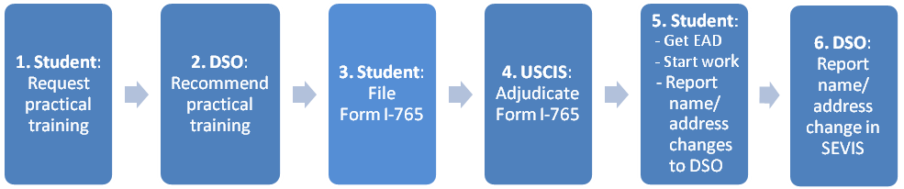

F-1 Optional Practical Training and Curricular Practical Training
For F-1 students, Optional Practical Training (OPT) and Curricular Practical Training (CPT) are options we encourage. Post-completion OPT allows one year of legally residing in, and working in the United States after graduation. This is a complex process and you should meet with the campus registrar for detailed instructions applying. Generally the process is:
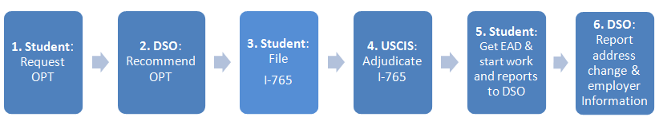

CPT allows for F-1 students to be paid while on their externship, before graduation, and provided the work is in the field of study. CPT is approved at the campus level. It is important to note that the amount of CPT time used may be deducted from approved OPT time.

J-1 Visa Options
If a student is interested in pursuing a J-1 Visa, you can contact one of the organizations listed below that may sponsor advanced culinary training. Please contact them for their individualized criteria for qualifying for a visa. The Institute of Culinary Education does not sponsor students for J-1 visas and is not affiliated in any way with the listed organizations.

http://www.culturalvistas.org/
http://www.interexchange.org/
http://www.hrc-international.com/
http://www.edintl.com/

M-1/F-1 VISA ACKNOWLEDGEMENT

- Immigration law requires M-1 visa students to be enrolled in a five-day morning or afternoon schedule in the Culinary Arts, Pastry & Baking Arts, Health-Supportive Culinary Arts, or Hospitality & Hotel Management Diploma Programs. F-1 visa students must be enrolled in an Associate’s program.

- M-1/F-1 students are not eligible to take the Culinary Management Program by itself. It may only be combined with either the Culinary Arts or Pastry & Baking Arts Programs. The Culinary, Pastry, or Health-Supportive Culinary Program in this circumstance must be taken in a Mon-Fri schedule.

- M-1/F-1 students must begin their externship immediately following their last class and be in attendance five days per week. No vacations or breaks are permitted.

- M-1/F-1 students are required to work 35 hours per week at their externships.

- If M-1 students are taking Culinary Management while on externship, the externship work requirement will be 22 hours per week. As soon as the Culinary Management Program ends, students are required to increase their work hours at the externship site to 35 hours per week.

- All students, including M-1/F-1 students, who are on externship are required to submit their attendance records weekly. In the event M-1/F-1 students fail to submit their attendance records, ICE is required to notify SEVIS electronically which will automatically terminate the students' visas.

- M-1 students are admitted to the United States for a fixed period of time necessary to complete the course of study indicated on their SEVIS form, plus an additional 30 days to depart the U.S. The total period of time cannot exceed one year. Therefore, all M-1 students must leave the U.S. within 30 days after the end date on their SEVIS form or 30 days after they complete their course of study at ICE, whichever is earlier. There are no extensions. M-1 students who fail to maintain a full course of study or otherwise fail to maintain their immigration status are not eligible for the additional 30-day period beyond the end date on the SEVIS form and must leave immediately.

- F-1 students are admitted to the United States for a fixed period of time necessary to complete the course of study indicated on their SEVIS form, plus an additional 60 days to depart the U.S. Therefore, all F-1 students must leave the U.S. within 60 days after the end date on their SEVIS form or 60 days after they complete their course of study at ICE, whichever is earlier. There are no extensions. F-1 students who fail to maintain a full course of study or otherwise fail to maintain their immigration status are not eligible for the additional 30-day period beyond the end date on the SEVIS form and must leave immediately.

- If M-1/F-1 students travel outside the U.S. during the course of study at ICE, they should have with them a valid passport with a valid M-1/F-1 visa in it and a current I-20 form for re-entry into the U.S. M-1/F-1 students should inform the Designated School Official in advance of any foreign travel plans to ensure that their documentation is in order. Upon re-entering the U.S., the student will be given a new I-94 arrival record form. The duration of the student's visa status, however, remains the period of time indicated on the I-20 form.

I, , have read the International Student
Guidelines and acknowledge and understand the details of what is required to maintain M-1 or F-1 visa student status. By signing I agree to comply with what is required to maintain M-1 or F-1 visa student status.

Student Signature: Date:

Verified by ICE: Date:

